# Django is a high-level Python web framework that encourages rapid development and clean, pragmatic design. Built by experienced developers, it takes care of much of the hassle of web development, so you can focus on writing your app without needing to reinvent the wheel. It’s free and open source.

# Requirement and tools

* Python
* PyCharm

# Follows these steps

Step 1. We need to open PyCharm and open any folder where you want to create a Django project also open the terminal.

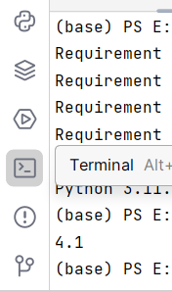

Step 2. Go to the terminal of PyCharm and type py -m pip install Django and hit enter.

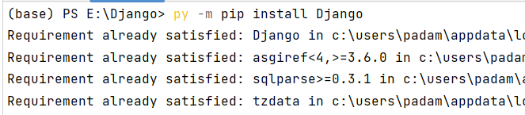

Step 3. If you want to check the version of Python type py –version and hit enter you get the version of Python.

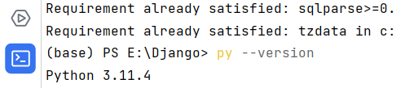

Step 4. If you want to check the version of Django then type django-admin –version and hit enter.

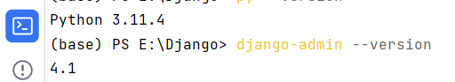

Step 5. After these all steps’ we need to create a project type django-admin startproject Myproject and hit enter. Here Myproject is my project name you can choose your own and after some time you get a new folder which has lots of files.

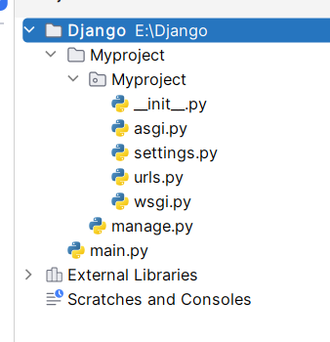

Step 6. Close everything and reopen you PyCharm and open your project my project name is Myproject also open terminal.



You can see you are inside of Myproject folder.

Step 7. Know type py manage.py runserver and hit enter and click on given link.

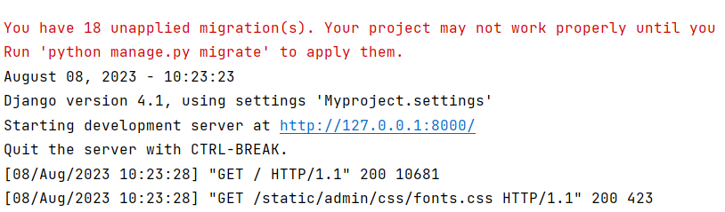

If you see this output-on web that’s mean you are successfully install Django.

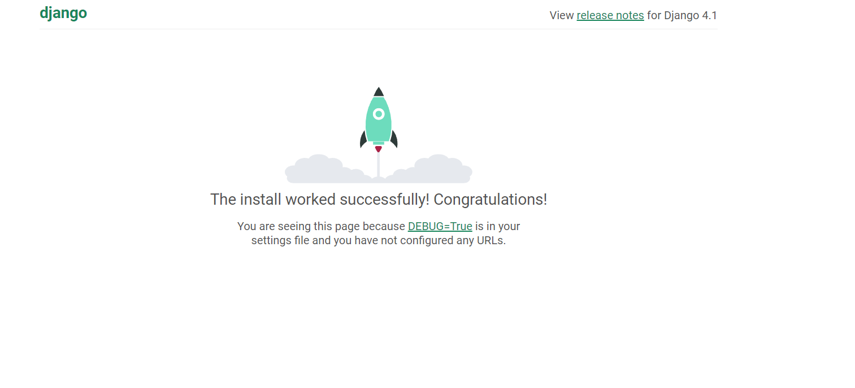

Print Hello World

# Know we are creating a function and printing Hello World on website.

Step 1. First, we need to create app into our project folder.

Step 2. Go to the terminal and type py manage.py startapp firstapp and hit enter you get a new folder inside of your project file (here firstapp is my app name you can choose as per your choice).

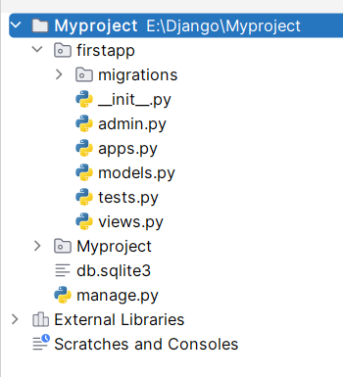

Step 3. Go to the firstapp folder and open view.py file and type this code.

from django.shortcuts import render  
from django.http import HttpResponse  
  
  
def index(request):  
  
 return HttpResponse("Hello, Welcome to Django")

Step 4. Create a new file inside the firstapp folder named urls.py and type this code.

from django.urls import path  
from . import views  
  
  
urlpatterns = [path('', views.index, name='index')]

Step 5. After this go to the Myproject folder and open urls.py file and type this code.

from django.contrib import admin  
from django.urls import path, include  
  
urlpatterns = [  
 path('', include('firstapp.urls')),  
 path('admin/', admin.site.urls),  
]

Step 6. After these steps open the terminal and type py manage.py runserver and click on link.

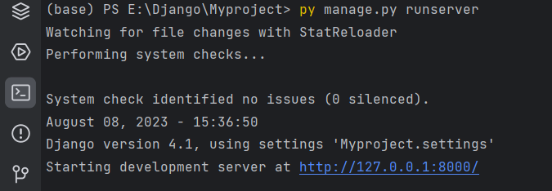

You get this output on web site.

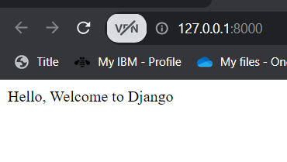

Create table with html

# Know we are creating a html file.

Step 1. Go to the firstapp folder and create a new directory whose name is templates.

Step 2. Inside of template we need an index.html file.

Step 3 type this code inside of index.html.

<!DOCTYPE html>  
<html lang="en">  
<head>  
 <meta charset="UTF-8">  
 <title>Title</title>  
</head>  
<style>  
 body{  
 background-color: grey;  
  
 }  
 th,td{  
 border: 2px solid red;  
 }  
</style>  
<body>  
 <table class="table" style="background-color: black; color:green; width:500px">  
 <thead>  
 <tr>  
 <th scope="col"></th>  
 <th scope="col">First</th>  
 <th scope="col">Last</th>  
 <th scope="col">Handle</th>  
 </tr>  
 </thead>  
 <tbody>  
 <tr>  
 <th scope="row">1</th>  
 <td>Mark</td>  
 <td>Otto</td>  
 <td>@mdo</td>  
 </tr>  
 <tr>  
 <th scope="row">2</th>  
 <td>Jacob</td>  
 <td>Thornton</td>  
 <td>@fat</td>  
 </tr>  
 <tr>  
 <th scope="row">3</th>  
 <td>Larry</td>  
 <td>the Bird</td>  
 <td>@twitter</td>  
 </tr>  
 </tbody>  
</table>  
</body>  
</html>

Step 4. Go to view.py file and add this code.

from django.shortcuts import render  
from django.http import HttpResponse  
from django.template import loader  
  
def index(request):  
 template = loader.get_template('index.html')  
 return HttpResponse(template.render())  
 # return HttpResponse("Hello, Welcome to Django")

Step 5. Know go to the Myproject folder the open setting.py and add below line inside of INSTALLED_APPS.

"firstapp.apps.FirstappConfig"

Step 6. Open terminal then type py manage.py runserver and hit enter also click on the given link.

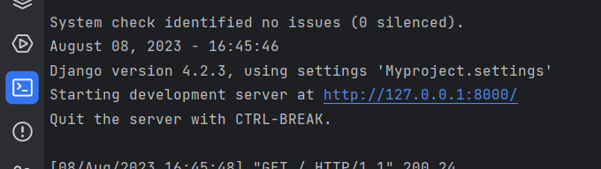

Step 7. If you get this that mean our Django work properly.

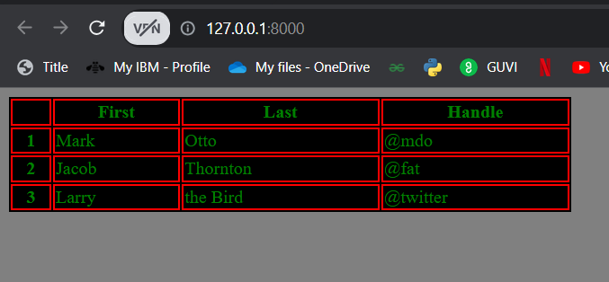

We are done with the installation and perform 2 activity’s print and html file.

Model View Templates

Step 1. First, we need to open PyCharm and go to the firstapp folder. Then open the models.py file and write this code inside of model.py

from django.db import models  
  
  
class Members(models.Model):  
 firstname = models.CharField(max_length=255)  
 lastname = models.CharField(max_length=255)

Step 2. Move to the terminal and type py manage.py makemigrations firstapp and hit enter (In place of firstapp you need to provide your app name I am go with my app name is firstapp then I am go with this).

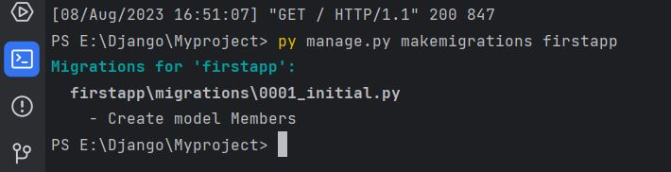

We get output like this.

Step 3. After step 2 you can see a migrations, folder created automatically.

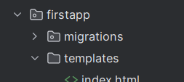

Step 4. Know type py manage.py migrate and hit enter you get a new file which name is 0001 into the migrations.

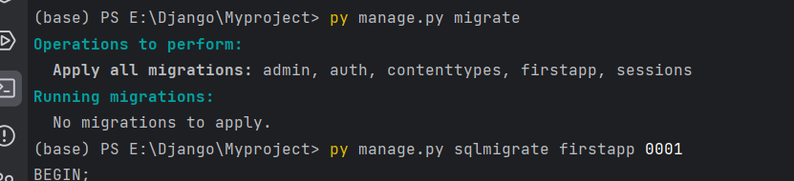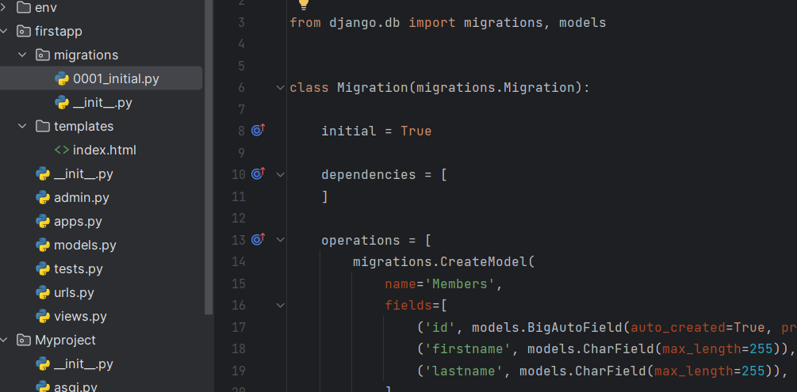

Step 5. For checking whether migration is done or not for this we need to type py manage.py sqlmigrate firstapp 0001 and hit enter.

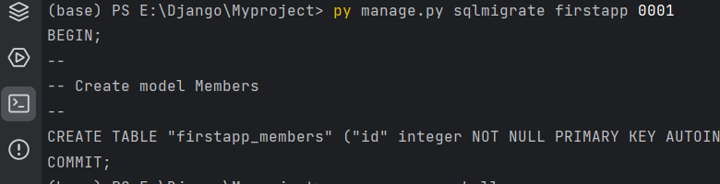

Step 6. Know we need to go shell command for this type py manage.py shell and hit enter. You are inside the shell command now.

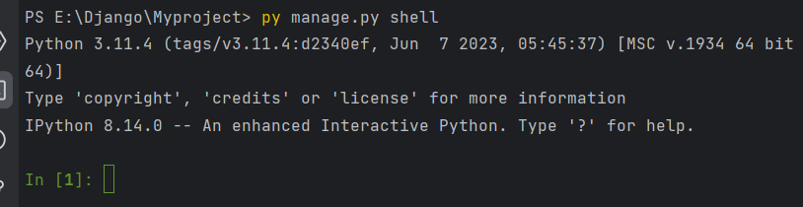

Step 7. Know type from firstapp.models import Members and hit enter.

Step 8. Type Members.objects.all() and hit enter.

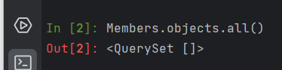

Step 9. Know type member= Members(firstname=’Riya , lastname=’Patil’) and hit enter. Then type member.save() to save the variable into the database.

Step 10. Type Members.object.all() and hit enter.

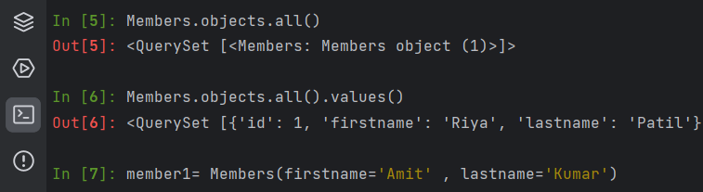

Step 11. Know to add some more records into the database type as like the image.

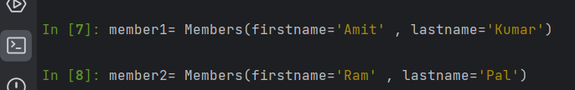

Step 12. Know save all records at a time for this create a list like this and hit 2 time enters.

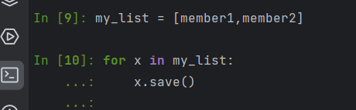

If you want to check it’s save or not then type Members.objects.all().values() to show the all saved records.

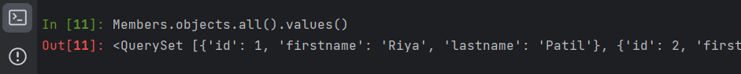

Step 13. Know to go to the firstapp folder and open the views.py file and write this code inside the view.py

from django.shortcuts import render  
from django.http import HttpResponse  
from django.template import loader  
from .models import Members  
  
def index(request):  
 mymembers = Members.objects.all().values()  
 template = loader.get_template('index.html')  
 context = {  
 'mymembers': mymembers  
 }  
 return HttpResponse(template.render(context,request))  
 # return HttpResponse("Hello, Welcome to Django")

Step 14. Go to models.py and write this line under the class 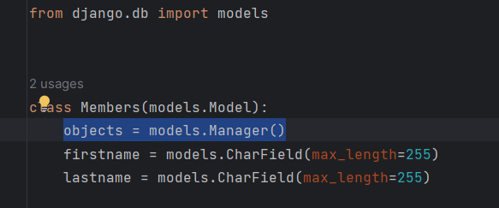

Step 15. Know out from the shell command.

Step 16. Create a index.html inside the templates folder.

<!DOCTYPE html>  
<html lang="en">  
<head>  
 <meta charset="UTF-8">  
 <title>Title</title>  
</head>  
<style>  
 body{  
 background-color: grey;  
  
 }  
 th,td{  
 border: 2px solid red;  
 }  
</style>  
<body>  
 <table class="table" style="background-color: black; color:green; width:500px">  
 {% for x in mymembers %}  
 <thead>  
 <tr>  
  
 <th>{{ x.id}}</th>  
 <th>{{ x.firstname}}</th>  
 <th>{{ x.lastname}}</th>  
 </tr>  
 </thead>  
 {% endfor %}  
  
</table>  
</body>  
</html>

Step 17: simpley type py manage.py runserver and hit enter.

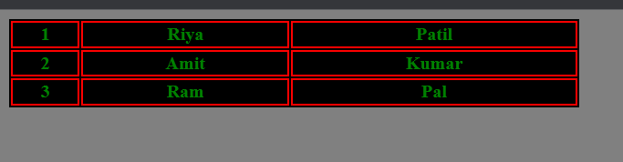

We have done the Models and view on HTML page.